Lab 1 (2%)

Join, group by, having, views

**topics**

join, group by, having, views

**Group work acknowledgment**

We, Aria Shakibai and Mansoor Zafar, declare that the attached assignment is our own work in accordance with the Seneca Academic Policy. No part of this assignment has been copied manually or electronically from any other source (including web sites) **or distributed to other students.**

Specify below what each member has done towards the completion of this work:

Name Task(s)

1- Mansoor Zafar Questions[6, 7, 8, 9, 10] (5 questions)

2- Aria Shakibai Questions[1, 2, 3, 4, 5 ] (5 questions)

**Before you start**

You are to create a new database named “AviaCo” and run the sql script you are given to create the tables in the database.

**Instructions**

For each of the following questions write the sql query (in text) and show the result set underneath each SQL query.

1. Show all charter trip codes and their crews (show the crew employee number, first and last name and the crew job).

Order the rows by charter trip number.

select top 5 c.CHAR_TRIP, e.EMP_NUM, e.EMP_LNAME, e.EMP_FNAME, c.CREW_JOB

from EMPLOYEE as e

inner join CREW as c on c.EMP_NUM = e.EMP_NUM

order by c.CHAR_TRIP

Output: first 5 rows out of 24 rows

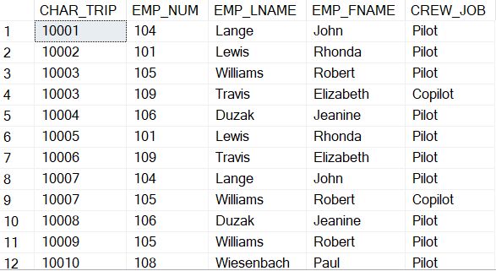

1. Show all charter trip code, date, destination, distance and hours flown and charter crews (show the crew employee number, first and last name and the crew job).

Order the rows by charter trip number.

Format the charter dates based on format code 1 (MM/DD/YY)

select top 5 c.CHAR_TRIP, CONVERT(varchar, c.CHAR_DATE, 1) as 'char_date',

c.CHAR_DESTINATION, c.CHAR_DISTANCE, c.CHAR_HOURS_FLOWN,

e.EMP_NUM, e.EMP_LNAME, e.EMP_FNAME, cc.CREW_JOB

from CHARTER as c

join CREW as cc on cc.CHAR_TRIP = c.CHAR_TRIP

join EMPLOYEE as e on e.EMP_NUM = cc.EMP_NUM

order by c.CHAR_TRIP

Output: first 5 rows out of 24 rows

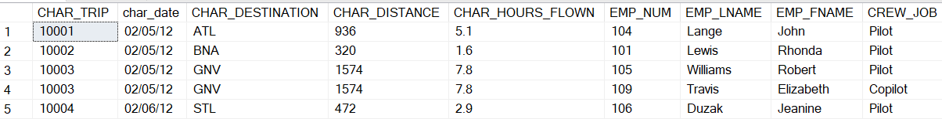

1. Show all customers (the customer code, first and last name) and their booked charter trips (show the charter codes, date, destination, distance, hours flown) and charter crews (show the crew employee number, first and last name and the crew job).

select top 20 percent customer.CUS_CODE, customer.CUS_FNAME, customer.CUS_LNAME,

charter.CHAR_TRIP, convert(varchar, charter.CHAR_DATE, 1) as 'char_date',

charter.CHAR_DESTINATION, charter.CHAR_DISTANCE, charter.CHAR_HOURS_FLOWN,

employee.EMP_NUM, employee.EMP_LNAME, employee.EMP_FNAME, crew.CREW_JOB

from customer

inner join charter on charter.CUS_CODE = customer.CUS_CODE

inner join crew on crew.CHAR_TRIP = charter.CHAR_TRIP

inner join employee on employee.EMP_NUM = crew.EMP_NUM

order by customer.CUS_CODE

Output: first 5 rows out of 24 rows



1. Show all aircraft model codes and the number of aircrafts associated with each.

select aircraft.MOD_CODE, count(aircraft.MOD_CODE) as 'count'

from aircraft

group by aircraft.MOD_CODE

Output:

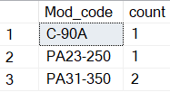

1. show the customers and the number of charters they have booked. Show the customer code, last and first name (all concatenated) and the number of associated charters.

select (select concat(customer.CUS_CODE, ',', customer.CUS_FNAME, ' ',

customer.CUS_LNAME) from customer where customer.CUS_FNAME = c.CUS_FNAME) as Customer,

(select count(*) from CHARTER where charter.CUS_CODE = c.CUS_CODE ) as nb_of_charters

from customer c

where (select count(*) from CHARTER where charter.CUS_CODE = c.CUS_CODE ) > 0

Output:

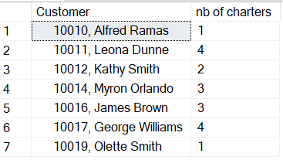

1. show the crew and the number of charters they were on. Result set should include emp_num, emp_fname, emp_lname, and number of charters.

select distinct employee.EMP_NUM, employee.EMP_FNAME, employee.EMP_LNAME,

(select count(*) from crew, charter where employee.EMP_NUM = crew.EMP_NUM and

crew.CHAR_TRIP = charter.CHAR_TRIP) as 'number of charters'

from employee, crew, charter

where (select count(*) from crew, charter where employee.EMP_NUM = crew.EMP_NUM and

crew.CHAR_TRIP = charter.CHAR_TRIP) > 0

order by employee.EMP_NUM

Output:

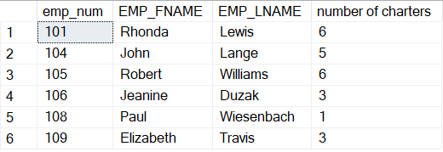

1. Extract the first two characters of the model code and count the number of aircrafts for each.

select substring(aircraft.MOD_CODE,1,2) as 'Manufacturer code',

count(aircraft.AC_NUMBER) as 'count'

from aircraft

group by substring(aircraft.MOD_CODE,1,2)

Output:

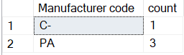

1. Show all charter trip codes, the charter distance and whether the distance is less than 1000 miles or larger than 1000 miles.

use IIF function, <https://www.w3schools.com/sql/func_sqlserver_iif.asp>

select top 5 charter.CHAR_TRIP, charter.CHAR_DISTANCE, iif(charter.CHAR_DISTANCE <

1000, '<=1000', '>1000') as 'flag'

from charter

Output: first 5 out of 18

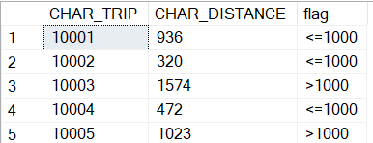

1. Count the number of charters whose distance is less than 1000 and those that have a distance larger than 1000. Then calculate the proportions of the charters in each bin.

-- cast the count as float so you get the ratio instead of 0.

use IIF function, <https://www.w3schools.com/sql/func_sqlserver_iif.asp>

select distinct iif(charter.CHAR_DISTANCE < 1000, '<=1000', '>1000') as 'distance',

round((cast(iif(charter.CHAR_DISTANCE < 1000,

(select count(c.CHAR_DISTANCE) from charter c where c.CHAR_DISTANCE <= 1000),

(select count(c.CHAR_DISTANCE) from charter c where c.CHAR_DISTANCE > 1000)) as float))

/ (select count(*) from charter), 2) as 'nbCharters'

from charter

Output:

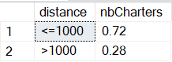

1. show the total fuel consumption, the total distance traveled, and the total hours flown per aircraft for aircrafts whose total hours flown is more than 15 hours.

select distinct aircraft.AC_NUMBER,

(select SUM(charter.CHAR_DISTANCE) from charter where charter.AC_NUMBER =

aircraft.AC_NUMBER) as 'totdistance_flown',

(select SUM(charter.CHAR_HOURS_FLOWN) from charter where charter.AC_NUMBER =

aircraft.AC_NUMBER) as 'tothrs_flown',

(select SUM(charter.CHAR_FUEL_GALLONS) from charter where charter.AC_NUMBER =

aircraft.AC_NUMBER) as 'fuel'

from aircraft

where (select SUM(charter.CHAR_HOURS_FLOWN) from charter where charter.AC_NUMBER =

aircraft.AC_NUMBER) > 15

Output:

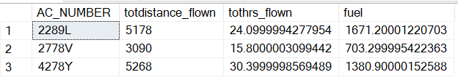

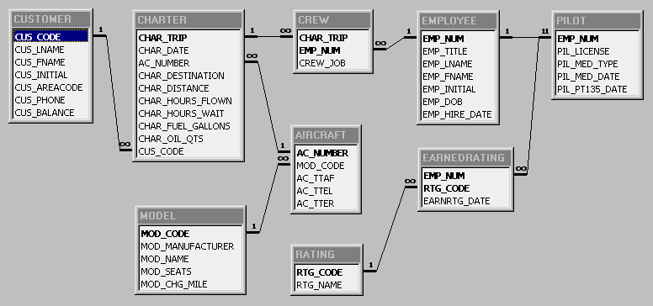

*Figure 1: The AviaCo_2-Relational Diagram*

**SUBMISSION**

Submit your lab1_GroupX.doc file on BB. Replace X with your group number.

If a student does not contribute to the work, do not list his/her name(s) under the group section in the lab file and will get 0.

**Grading rubrics**

Each question is worth 5pts. Total is 50 pts.

If the output is included without the query, the answer is worth 0.